Curating Community Digital Collections Program Logistics: Description of Contents
The zip drive directory structure and files are described below. Folder contents include contextual information, and examples and templates that could be modified by other organizations to build and launch a program like Curating Community Digital Collections (CCDC).
(1) Grant Program Documentation
This folder contains the program summary narrative and timeline from our IMLS grant proposal, a more detailed annual program timeline for 2018, our program “core values” document and two progress reports submitted to IMLS.
- Grant Narrative: Describes the program, goals and activities.
- Schedule of Completion: Two-year timeline with key activities delineated each month.
- Program Design and Implementation: How we designed and implemented this program, including lessons learned. *
- Program Timeline: Year One (2018) timeline with key activities and due dates.
- Core Values: Fundamental principles and expectations for all CCDC program participants.
- Year One Report (IMLS): Interim Performance Report to IMLS (2018).
- Year Two Report (IMLS): Interim Performance Report to IMLS (2019).
(2) Application Process
This folder contains communications and documents used to facilitate the program application process for students and host sites, and general expectations for key participants – students, host site supervisors and mentors.

Host Sites
- Outreach Email: Template text for announcing program to potential host sites.
- Sample Host Site Application: Application process created using Google Forms. Sample application from accepted applicant.
- Acceptance Email: Template text for informing selected host sites.
- Host Site Supervisor Expectations: General expectations for participating host sites.

Students
- Application Process: Describes application process for potential student participants.
- Application Flyer: Describes application process for potential student participants.
- Interview Questions: Sample interview questions for student applicants.
- Acceptance Emails: Template text for informing selected students.
- Outreach Emails to Information Schools’ Graduate Programs: Describes program and application process for information school staff.
- Student Expectations: General expectations for participating students.

Mentors
- Mentor Expectations: General expectations for participating mentors.
(3) Summer Program Preparation
This folder contains materials and communications created to prepare for the CCDC Immersion Workshop. This does not include the Workshop curriculum which is available here [link to curriculum].
- Spring Host Site Visit Questionnaire: Administered mid-summer, in preparation for program coordinator’s site visit to selected host sites. Used to facilitate summer project planning and Immersion Workshop curriculum development.
- Graduate Student Program Requirements: Information shared with program participants, to better understand selected students’ academic requirements associated with their CCDC summer fieldwork experiences.
- Pre-Workshop Email (1): Outreach to participants including workshop preparation and details.
- Pre-Workshop Email (2): Outreach to participants including workshop preparation and details.
- Pre-Workshop Readings: Suggested readings and “homework” to prepare participants for the CCDC Immersion Workshop.
- Workshop Event Registration: Google Form to gather information from workshop participants including dietary requirements, accessibility requirements, arrival and departure dates/times, and technology needs (e.g. laptop, etc.).
- Workshop Tips: Tips for putting on an effective workshop including planning checklist and lessons learned.
- CCDC Immersion Workshop Agenda: Agenda for three-day workshop to prepare participants to complete their digital preservation projects.
- Google Suite: Tips for using Google Suite (Docs, Sheets) as a shared work and project management environment for CCDC.
(4) Summer Program
This folder contains schedules, checklists and communications to support the summer program including the end-of-summer virtual capstone meeting materials and selected resources created by our students for their individual host sites and projects.
- Summer Schedule: Target timeline and detailed checklist for students. Used by students, host sites and mentors to track work throughout the summer.
- Mentor Check-in Checklist: Schedule for mentors that delineates specific topics and benchmarks to discuss with students during three required summer check-in meetings.
- Summer Site Visit Agenda: Template agenda for mid-summer site visits by program coordinator to host sites.
- Program Wrap-up Email: Final summer email to program participants.
Virtual Capstone
- Agenda for end-of-summer virtual capstone event.
- Virtual Capstone (2018): 2018 Virtual Capstone meeting slide deck.
- Virtual Capstone (2019): 2019 Virtual Capstone meeting slide deck.
(5) Outreach
This folder contains materials and information created to communicate and promote the program including logos, infographics, blog posts, selected conference or meeting presentations, and case studies.
- CCDC logos (2): Example of logos created for the CCDC program.
- Points of Pride Infographic: Infographic presenting program accomplishments in year one.
- Summer blog posts: Blog posts written through the summer by student and host site supervisors. Accessible on the CCDC web site. https://recollectionwisconsin.org/category/ccdc
- PR Template: Press Release template for host sites to share their participation in CCDC.
- Case Study Template: Template used to create CCDC program participants case study.
- Barron County Historical Society Case Study (2018): Sample case study from CCDC participant.
Presentations
A selection of presentations about CCDC, delivered during the grant period.
- NEDCC Symposium (2018): Slide deck. Presentation introducing CCDC.
- Wisconsin Library Association (2018): Slide deck. Presentation introducing CCDC.
- DPLAFest 2019: Slide deck. Presentation introducing CCDC and reviewing year one accomplishments and lessons learned.
- WiLSWorldShorts (2019): Slide deck. Advocating for digital preservation.
(6) Evaluations
This folder contains reports and survey results from various program assessment activities including a post-workshop survey of attendees and six-month and two-year post-program surveys of participants.
- Skills Inventory: Used to measure program participants experience and skills related to digital preservation work. Administered twice - before and after the Immersion Workshop.
- Post-workshop Participant Feedback (2018): Created in Survey Monkey. Short survey completed by workshop participants to inform future events and programs.
- Post-workshop Participant Feedback (2019): Created in Survey Monkey. Short survey completed by workshop participants to inform future events and programs.
- Six Month Survey (2018): Created using Survey Monkey. Survey completed by CCDC participants (students and site supervisors) six months after completing their program.
- Six Month Survey (2019): Created using Survey Monkey. Survey completed by CCDC participants (students and site supervisors) six months after completing their program.
- Two Year Survey (2020)

Acknowledgments
For more information, visit Curating Community Digital Collections: https://recollectionwisconsin.org/digipres
Thank you to AVP senior consultant, Amy Rudersdorf, who helped develop and deliver our immersion workshop training: www.weareavp.com.
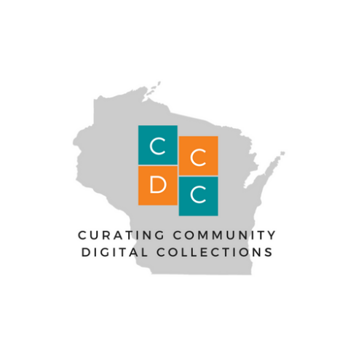
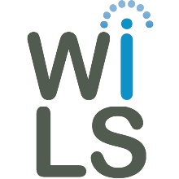
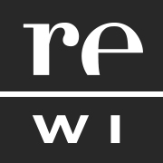
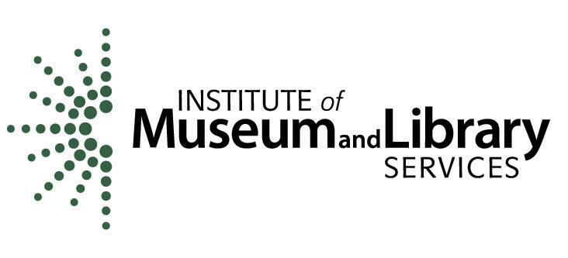
This project was made possible by the Institute of Museum and Library Services, #RE-85-17-0127-17.

