Immersion Workshop Curriculum and Materials
Curating Community Digital Collections (CCDC)

The following curriculum and materials were delivered as part of a three-day digital preservation immersion workshop for CCDC host site supervisors, students, and mentors in 2018 and 2019.

Digital Preservation Concepts, Contexts and Key Terms
- Digital Preservation Concepts, Contexts and Key Terms: slide deck
Emily Pfotenhauer, WiLS/Recollection Wisconsin
- CCDC glossary
- Workshop resources

Digital Preservation Models and Approaches
- Digital Preservation Models and Approaches: slide deck
Emily Pfotenhauer, WiLS/Recollection Wisconsin

Introduction to Digital Preservation Policy Creation
- Digital Preservation Policy Creation: slide deck
Vicki Tobias, WiLS/Recollection Wisconsin
- Digital preservation policy-creation worksheet/template
- Sample digital preservation policies and workflows
  - Laura Vavrosky – Richard I. Bong Veterans Historical Center (2019)
  - Kristina Warner – Outagamie Waupaca Library System (2018)
  - Kristen Whitson – UW-River Falls Archives (2019)

Identifying and Documenting Digital Collections
- Identifying and Documenting Digital Collections: slide deck
Amy Rudersdorf, AVP
- Collections inventory template: spreadsheet

Assessing and Prioritizing Digital Collections
- Assessing and Prioritizing Digital Collections: slide deck
Amy Rudersdorf, AVP
- Selection exercise handout

Digital Storage 101
- Digital Storage 101: slide deck
Dorothea Salo, UW-Madison Information School
- Digital storage 3-2-1 plan/worksheet

File Naming and Organization
- Why is File Naming Important?: slide deck
Amy Rudersdorf, AVP
- File naming exercise
- Sample files and metadata used with exercise
- Advanced Renamer help sheet

File Integrity and Fixity Checking
- File Fixity and Data Integrity: slide deck
Amy Rudersdorf, AVP
- Fixity user guide, v1.2 (AVP)
- Fixity user guide, Kristina Warner, OWLS

Guest Presentations
- Introduction to DPLA and Recollection Wisconsin
Emily Pfotenhauer, WiLS/Recollection Wisconsin
slides
- How to talk to IT about digital preservation
Scott Prater, UW-Madison Digital Library Services
slides | article
- Digitization best practices and standards
Jesse Henderson, UW Digital Collections Center
slides from 2018
- Oral histories and storytelling projects
Paul Hedges, Wisconsin Historical Society
slides
- UW Libraries Digital Preservation Task Force
Kristin Briney, UW-Milwaukee and Heather Stecklein, UW-Stout
slides from 2018

Acknowledgements
For more information, visit Curating Community Digital Collections: https://recollectionwisconsin.org/digipres
Thank you to AVP senior consultant, Amy Rudersdorf, who helped develop and deliver our immersion workshop training: www.weareavp.com.
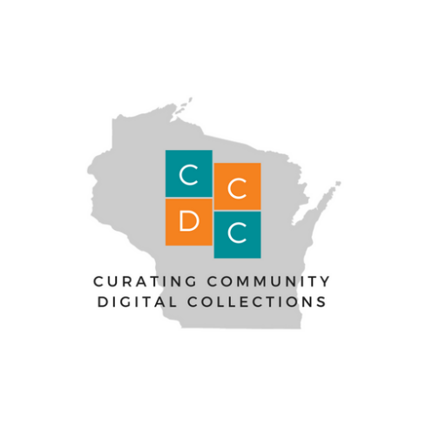
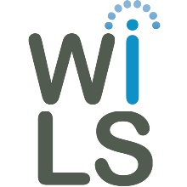
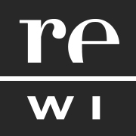
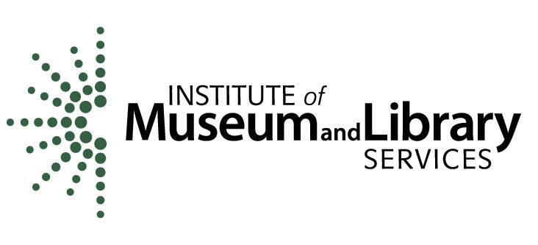
This project was made possible by the Institute of Museum and Library Services, #RE-85-17-0127-17.

