Checklist for Planning and Launching Curating Community Digital Collections (CCDC)

Grant Program Planning
- Develop budget and acquire funding
- Hire program coordinator
- Identify virtual communication platforms and tools for project
- Build and populate program website with key program information

Application Process
- Outreach to information school programs
- Outreach to potential host sites
- Student application process
- Select students
- Coordinate with information school program staff
- Host site application process
- Select host sites
- Select mentors

Summer Program Preparation
- Spring visit to selected host sites
- Review and further develop individual project plans with host sites
- Match students/host sites/mentors and announce teams
- Set up Google Drive or other virtual work and communication environments
- Pre-workshop communications and activities
  - Workshop logistics
  - Readings and homework
- Plan Immersion Workshop
  - Location
  - Accommodations
  - Transportation
  - Food + beverages
  - A/V set up
  - Agenda
- Develop Immersion Workshop curriculum
  - Activities
  - Lectures/presentations
- Post-workshop evaluation

Summer Program
- Launch summer program
- Stipends and reimbursements
- Communication, outreach and blog posts
- Mid-summer site visits to host sites – all team members + program coordinator
- Virtual capstone event

Outreach, Reporting and Evaluations
- Six-month evaluations
- Two-year evaluations
- Outreach
- Presentations and publications
- Interim reports to funding agency
- Final reports to funding agency

Acknowledgments
For more information, visit Curating Community Digital Collections: https://recollectionwisconsin.org/digipres
Thank you to AVP senior consultant, Amy Rudersdorf, who helped develop and deliver our immersion workshop training: www.weareavp.com.
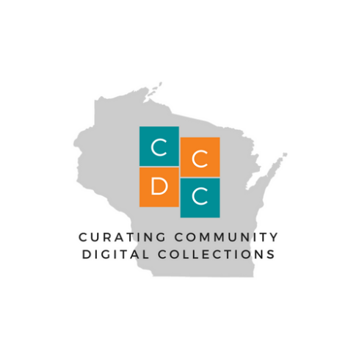
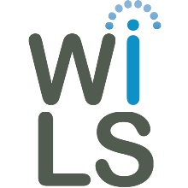
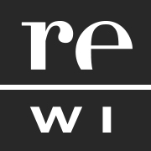
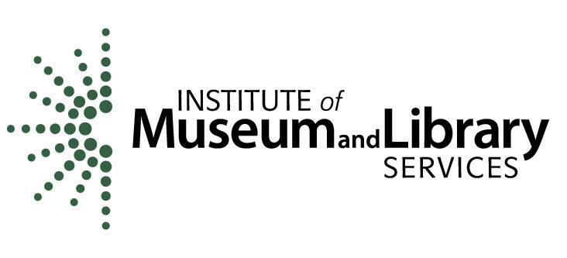
This project was made possible by the Institute of Museum and Library Services, #RE-85-17-0127-17.

